University of Central Punjab
BSSE FINAL PROJECT

Defense drill



Mam Rubab Javaid

Presented by:
Group ID:F22SE046

Student Reg# Student Name
L1f19bsse0128 Abdul Moiz Adnan
L1f19bsse0132 Hassan Islam
L1f19bsse0303 Rimsha Gafoor

Faculty of Information Technology

University of Central Punjab
University of Central Punjab
Complete System
SDP Phase IV
Defense Drill
Advisor: Mam Rubab Javaid

Group id: F22SE046
Member Name | Primary Responsibility
Abdul moiz adnan | 4,5
Hassan islam | 1,2,3,5,10
Rimsha gafoor | 7,8

Table of Contents `
Table of Contents ......................................................................................................................... i
Revision History ......................................................................................................................... ii
Abstract 1
1. Introduction 1
1.1 Product 1
1.2 Background 1
1.3 Objective(s)/Aim(s)/Target(s) 1
1.4 Scope 2
1.5 Business Goals 2
1.6 Document Conventions 2
2. Technical Architecture 3
2.1 Application and Data Architecture 3
2.2 Component Interactions and Collaborations 6
2.3 Architecture Evaluation 9
3. Detailed/Component Design 10
3.1 Component-Component Interface 10
3.2 Component-Human Interface 11
4. Screenshots/Prototype 12
4.1 Workflow 12
4.1 Screens 13
5. Test Specification and Results 19
5.1 Test Case Specification 19
6. Revised Project Plan 22
7. Deployment/Installation Guide 23
8 User Manual 24
9 References 26
10 Project Summary Form 27
Appendix B: IV & V Report 38

Revision History
Name | Date | Reason For Changes | Version

Abstract
Now a days due to rampant crimes in the country which have no end in sight, ordinary citizens are being caught up in situations they are not ready for. They are unable to protect themselves and those close to them because they do not have the required skillset to remain calm and act in accordance to avoid getting hurt, robbed, or killed. To counteract that we have developed an app which has courses for beginners as well as advanced users which will provide the user with the skillset to at-least defend themselves in dangerous situations.

At the end, the results that would be acquired are: provided the user with ability to defend themselves and make a citizen not so helpless in dangerous situations anyone. Intermediate users and advanced users could be eligible for a career in mixed martial arts by participating in a tournament to test their ability according to their badge levels.

Introduction

Product
Our project solves the problem plaguing our nation i.e., people having no form of self-defense/self-preservation ability. Our app provides that skill that is obtainable even after completing the most beginner course we offer.

Background
This Project aims to provide ordinary citizens with the knowledge and skill of self-defense. The tutors will also be able to sign up and upload their portfolios. The users will interact with the tutors through online seminar. This project provides the user beginner and if the user wishes to learn more, advanced skills which would enable the user to protect themselves and their loved ones in a dangerous situation. Complete new animations made by us to provide a visual representation of the martial arts move. The project also provides notifications of tournaments to pit users against each other according to badge/skill level. Freelance martial arts tutors can also hugely benefit from providing one-on-one lessons to confirming skill level for a fee. The app has image processing to ensure correct repetition of moves. This project has an app based designed to run efficiently on all systems with accurate responsiveness.

Objective(s)/Aim(s)/Target(s)
- We will make an app that provides a three-course program that teaches martial arts from beginner to the advanced level.
- An image processing module to calculate repetitions.
- A badge system that will award badges based on course completion. Complete new animations made by us to provide a visual representation of the martial arts move. Complete documentation and code of project

Scope
We will make an mobile app that provides a three-course program that teaches martial arts from beginner to the advanced level. The app would contain an image processing module to calculate repetitions. A badge system that will award badges based on course completion. The ability to create an account for user.

Business Goals
Our main business goals are:
- To provide martial arts training who cannot afford training institutes and outdoor tuitions.
- To provide earning platform for trainers.
- To provide free courses and paid online classes for trainee.

Document Conventions
This document uses the following conventions:

DDRL | Defense Drill
Main headings | Size 18 bold times new roman
Sub headings | Size 14 bold times new roman
Headings content | Font size 12 style Ariel

Technical Architecture

Application and Data Architecture

Architecture Diagram
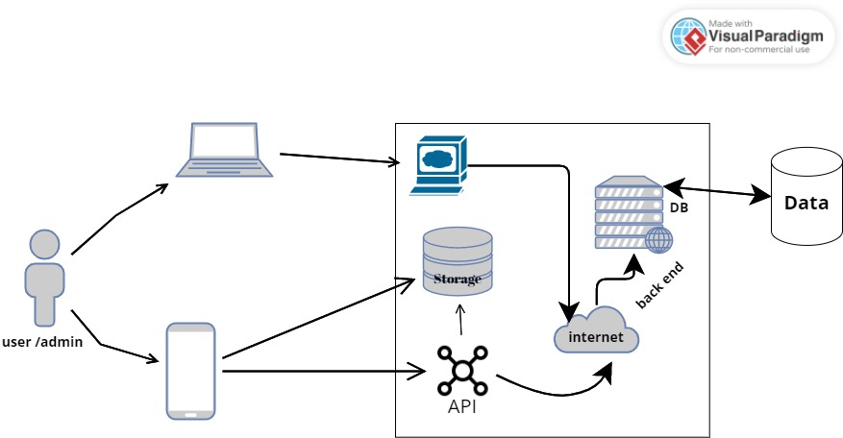

ERD diagram:

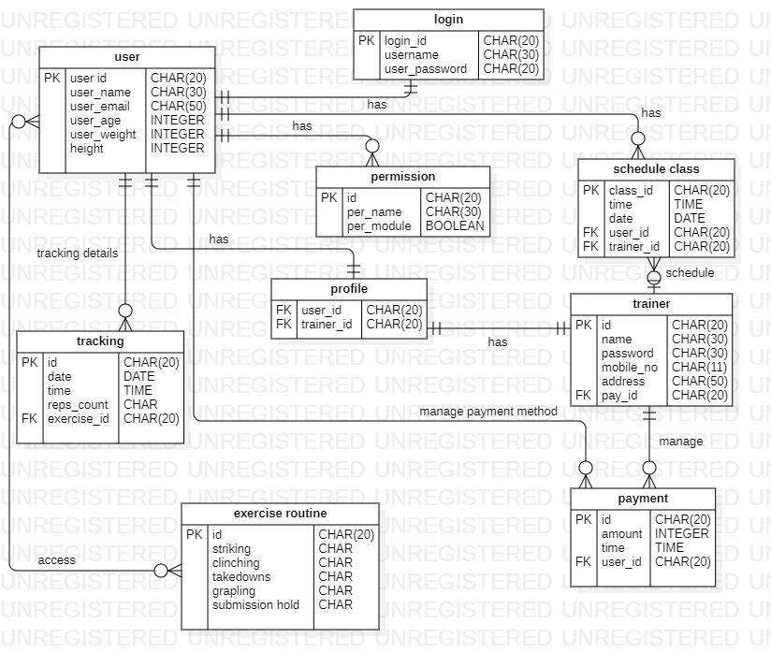

Class Diagram:
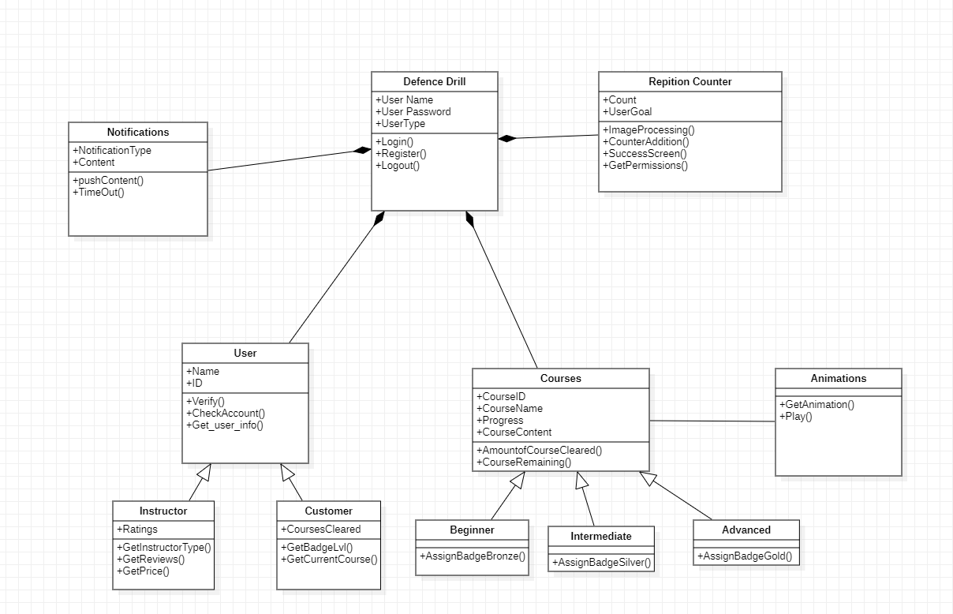

Activity Diagram:
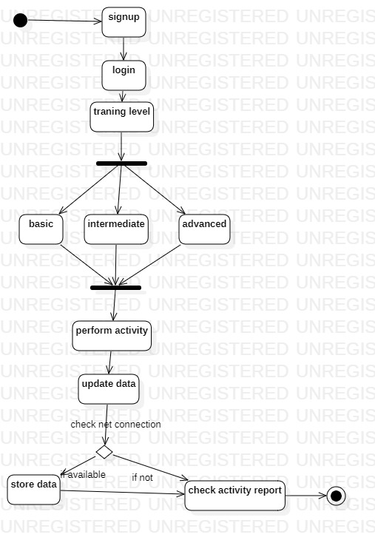

Component Interactions and Collaborations
Component Diagram:
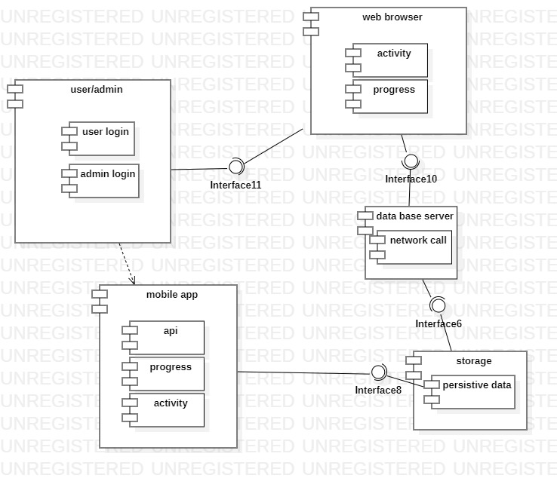

DFD
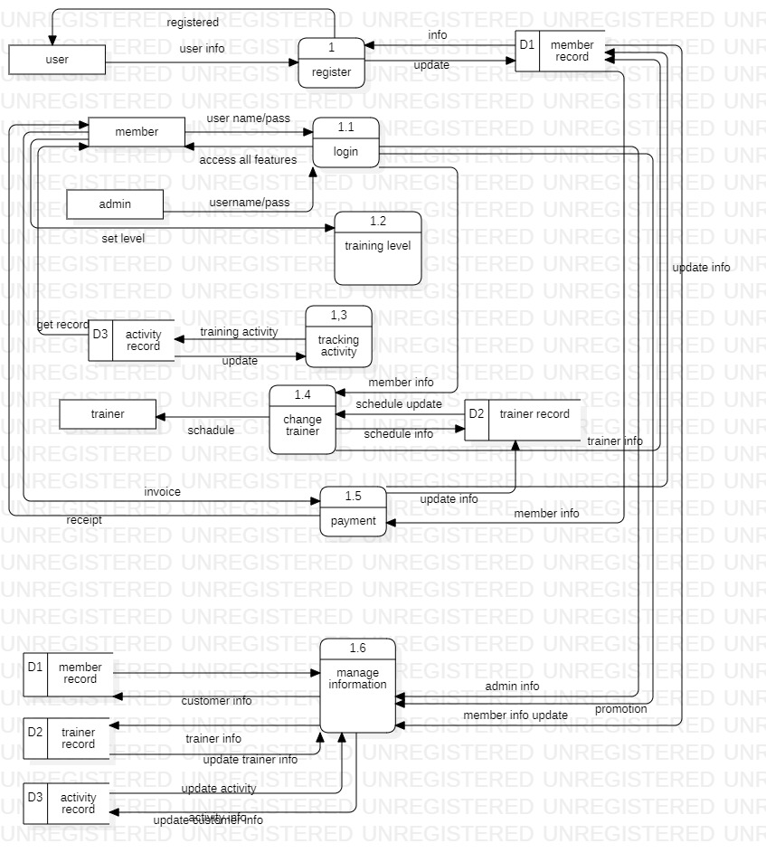

Architecture Evaluation

We use Computer vision technology in our project and the reason of using this technology is to analyze the images or video footage captured by the camera and track the movements and repitition of the user's body during martial arts training.

Pros:
- Accurate feedback: Computer vision technology can provide accurate feedback on the user's form and technique during martial arts training, which can be valuable for improving their skills.
- Real-time feedback: Computer vision technology can provide real-time feedback on the user's movements, allowing them to make adjustments and corrections as they train.
- Interactive experiences: Computer vision technology can enable the creation of interactive experiences within the application, such as virtual sparring or training exercises, that can enhance the user's training experience.
- Scalability: Computer vision technology can be scaled to accommodate a large number of users, making it suitable for use in a mobile application that is designed to reach a wide audience.
Cons:
- Complexity: Implementing computer vision technology in a mobile application can be complex and require specialized knowledge and expertise, which can increase development time and cost.
- Hardware limitations: Computer vision technology may require specific hardware requirements, such as high-quality cameras, that may not be available on all mobile devices.
- Environmental factors: Environmental factors, such as lighting conditions and background clutter, can affect the accuracy and reliability of computer vision technology in detecting motion.
- Privacy concerns: The use of computer vision technology in a mobile application may raise privacy concerns, as users may be uncomfortable with the collection and storage of their data.

Detailed/Component Design

Component-Component Interface
Sequence Diagram:
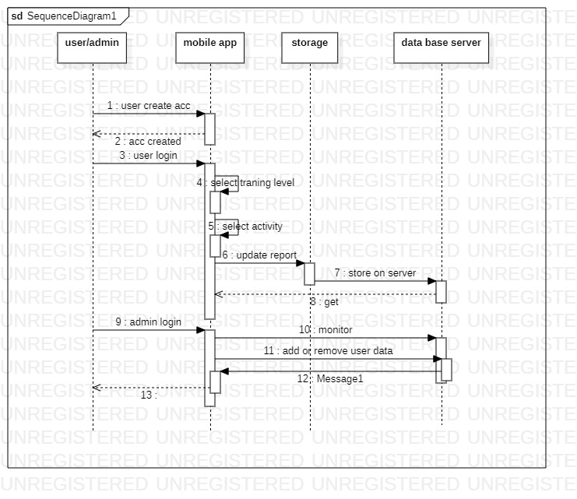

Component-Human Interface

- Login/Register screen - where users can log in to their existing account or create a new account
- Home screen - where users can see different sections of the app, such as training programs, virtual sparring, and progress tracking
- Training program screen - where users can select a specific martial arts training program
- User Profile screen - where users can view and update their personal information, such as their name, age, and martial arts experience
- Instructor profile screen-where trainer can see and update their informations and set their charges of classes etc
- Settings screen - where users can customize their app preferences, such as notifications and language options

Screenshots/Prototype

Workflow
Swimlane Diagram:
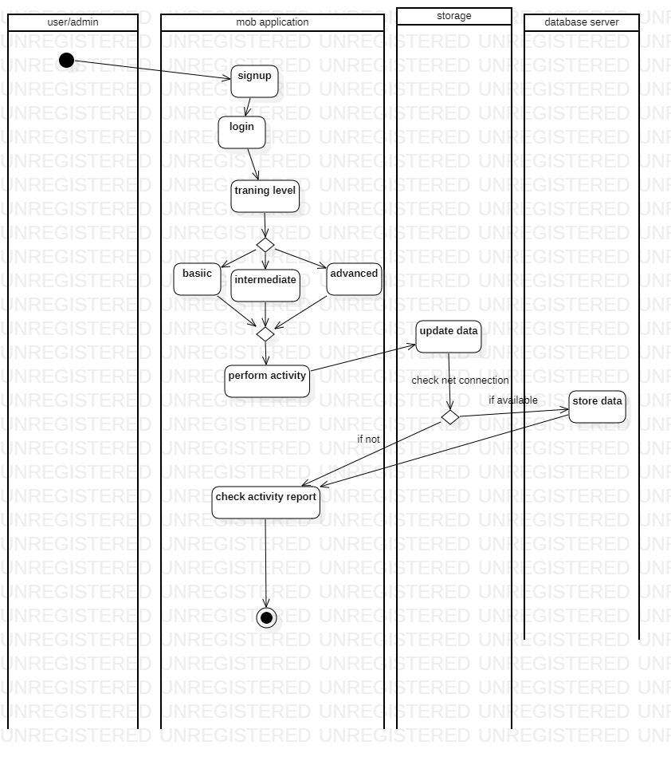

Screens
Sign in/ Sign up

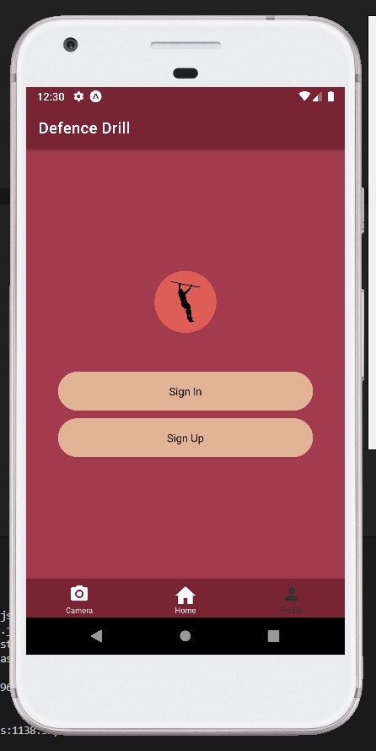

Sign up

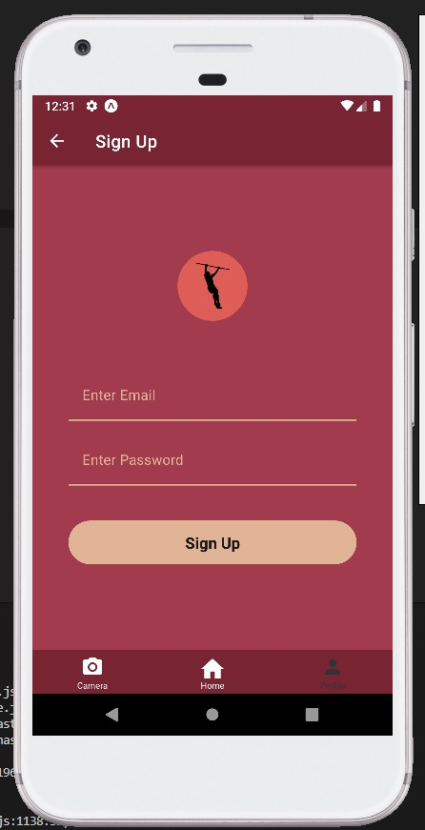

Sign out:
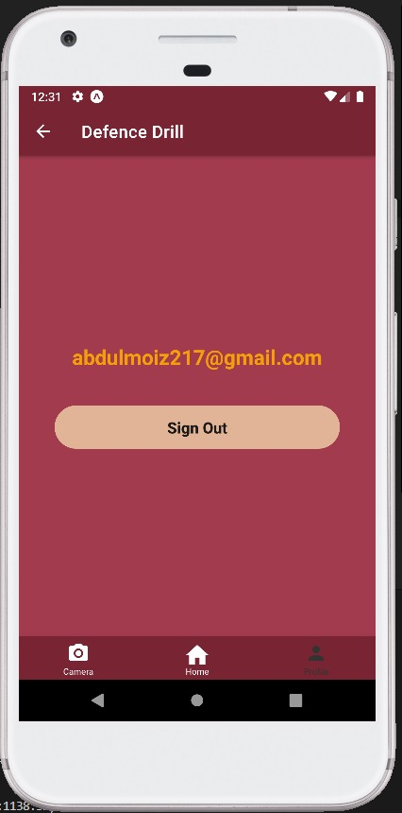

Levels
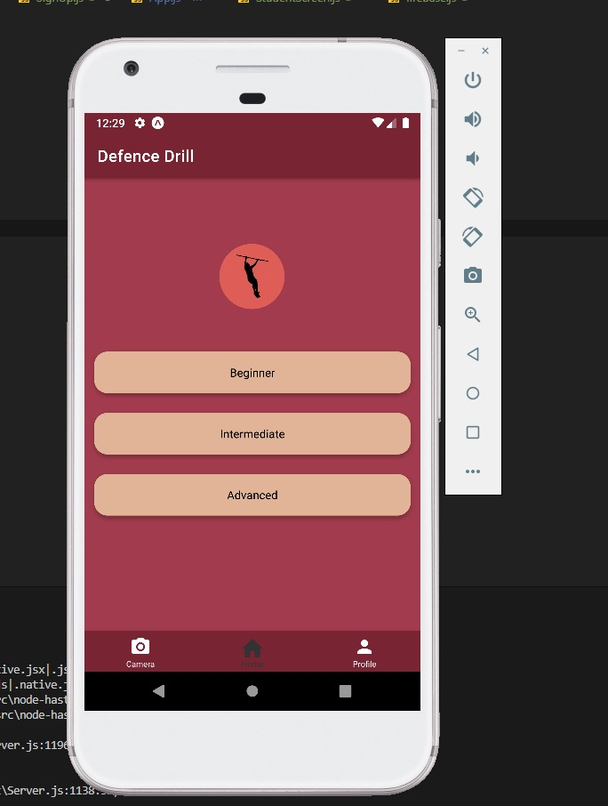

Beginner
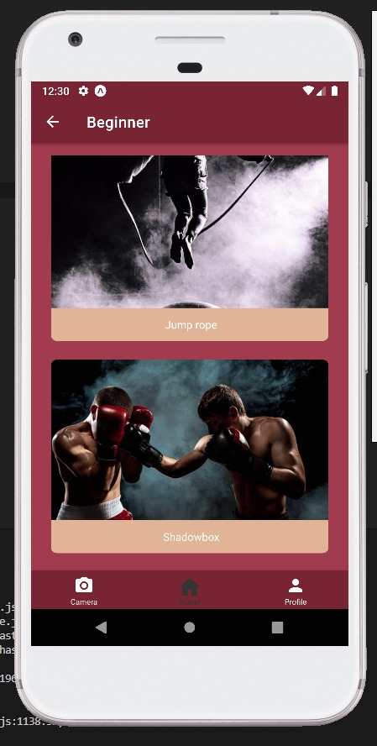

Intermediate
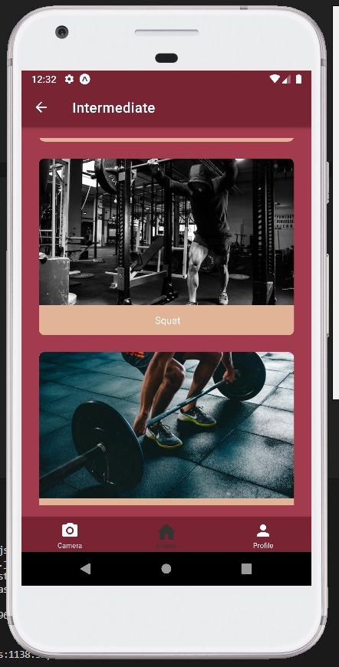

Camera:

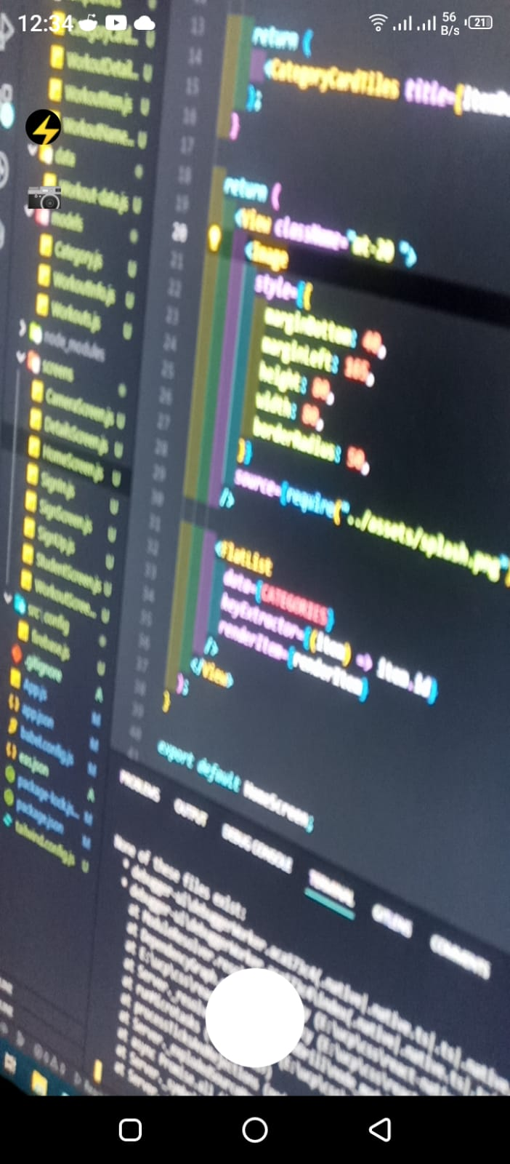

Test Specification and Results

Test Case Specification

Table 6.1: TC-1
Identifier | User login and registration
Related requirements(s) | User login and registration
Short description | Verify user can create an account and log in successfully
Pre-condition(s) | The application is installed on the user's device and the user has a stable internet connection.
Input data | Valid email address, username, and password
Detailed steps | - Open the application.  - Tap on the "Sign up" button.  - Enter a valid email address, username, and password.  - Tap on the "Create account" button.  - Check the confirmation email in the provided email inbox and click on the link to activate the account.  - Open the application.  - Tap on the "Log in" button.  - Enter the registered email and password.  - Tap on the "Log in" button.
Expected result(s) | User should be able to successfully create an account and log in without any errors.
Post-condition(s) | User account is created and logged in successfully.
Table 6.1: TC-2
Identifier | profile
Related requirements(s) | User profile management
Short description | Verify user can update their profile information
Pre-condition(s) | User is logged in to their account.
Input data | Updated user information
Detailed steps | - Open the application.  - Tap on the user profile icon.  - Tap on the "Edit profile" button.  - Update any desired fields (e.g., name, profile picture, training level, etc.).  - Tap on the "Save changes" button.
Expected result(s) | User profile should be updated with the new information.
Post-condition(s) | User profile is updated successfully.

Table 6.1: TC-3
Identifier | Programs
Related requirements(s) | Training program selection
Short description | Verify user can select a training program
Pre-condition(s) | User is logged in to their account.
Input data | User is logged in to their account.
Detailed steps | - Open the application.  - Tap on the "Training programs" button.  - Select a desired training program.  - Tap on the "Select" button.
Expected result(s) | User should be able to select a training program without any errors.
Post-condition(s) | User has selected the desired training program.
Table 6.1: TC-4
Identifier | User login and registration
Related requirements(s) | Workout tracking
Short description | Verify user can track their workouts
Pre-condition(s) | User is logged in to their account and has selected a training program.
Input data | Workout tracking data
Detailed steps | - Open the application.  - Tap on the selected training program.  - Select the desired workout session.  - Tap on the "Start" button to begin the workout.  - Follow the workout instructions and record the data (e.g., reps, sets, weights, etc.).  - Tap on the "Complete" button when finished.
Expected result(s) | User should be able to track their workout data without any errors.
Post-condition(s) | Workout data is recorded and saved to the user's account.
Table 6.1: TC-5
Identifier | tutorials
Related requirements(s) | Animation tutorials
Short description | Verify user can watch Animation tutorials
Pre-condition(s) | User is logged in to their account and has selected a training program.
Input data | Animation tutorial selection
Detailed steps | - Open the application.  - Tap on the selected training program.  - Select the desired Animation tutorial..  - Watch the Animation tutorial in its entirety.
Expected result(s) | User should be able to watch Animation tutorials without any errors.
Table 6.1: TC-6
Identifier | Change program
Related requirements(s) | Training program customization
Short description | Verify user can create a custom training schedule
Pre-condition(s) | User is logged in to their account and has selected a training program.
Input data | User custom training schedule
Detailed steps | - Open the application.  - Navigate to the selected training program.  - Tap on the "Create Custom Schedule" button.  - Select the start date and end date for the custom training schedule.  - Choose the days of the week and time slots for each training session.  - Save the custom training schedule.  - View the custom training schedule in the "My Training Schedule" section.
Expected result(s) | User should be able to create a custom training schedule that fits their individual needs and preferences
Post-condition(s) | User has created a custom training schedule.

Revised Project Plan
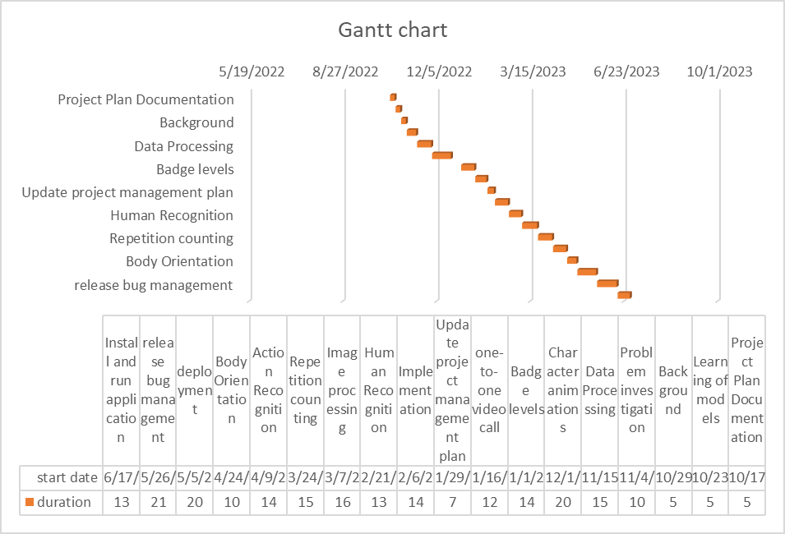

Table 6.2: Project Completion Status
Module Name | Status  (Complete, Partially Implemented, Not Implemented)
User profile | Completed
Instructor profile | Completed
Badge system | Completed
Training modes | Completed
Animated clips | Completed
Repetition counter using openCV | Implemented
Progress track | Not implemented
Schadule | Not implemented

Deployment/Installation Guide

System Requirements:
- Before installing the application, ensure that your device meets the following requirements:
- Operating System: Android 6.0 (Marshmallow) or later, iOS 12 or later.
- Memory: Minimum 2GB RAM.
- Storage: Sufficient free storage space for the application and downloaded content.
- Camera: A device with a front-facing camera is required for the repetition counting feature.

Download and Installation:
Follow the steps below to download and install the Martial Arts Training Mobile
Application:
For Android:
- Open the Google Play Store on your Android device.
- Search for "Martial Arts Training" in the search bar.
- Locate our application in the search results and tap on it.
- Tap the "Install" button to begin the installation process.
- Once the installation is complete, tap "Open" to launch the application.

Application Setup:
- Upon launching the application for the first time, you will be guided through the initial setup process. Follow the on-screen instructions to complete the setup, including granting necessary permissions (e.g., camera access) and creating a user profile.

Training Levels:
- The Martial Arts Training Mobile Application offers three levels of training: basic, intermediate, and advanced. To switch between levels, follow these steps:
- Open the application and log in using your credentials.
- Navigate to the main menu or dashboard.
- Look for an option labeled "Training Levels" or similar.
- Tap on the desired training level to access the corresponding training content.

Animated Training GIFs:
The application provides animated training GIFs to help you better understand the
techniques. To access the GIFs:
- Open the application and select the desired training level.
- Within each training session, you will find instructional GIFs accompanying the exercises.
- Tap on the GIFs to play or pause them as needed.
- Use the on-screen controls to navigate through the GIFs or replay them.

Repetition Counting via Camera:
The application utilizes your device's camera to count the repetitions during exercises. To
use this feature:
- Open the application and select the desired training level.
- Choose an exercise that supports repetition counting.
- Position your device in a stable position, ensuring the exercise is visible within the camera frame.
- Start performing the exercise while keeping it within the camera's view.
- The application will track your movements and count the repetitions automatically.

Troubleshooting:
If you encounter any issues or need assistance with the application, please refer to the
following resources:
- FAQs and troubleshooting section within the application.
- User support forum or community on our website.
- Contact our customer support team via email or phone for further assistance.

Congratulations! You are now ready to deploy and install our Martial Arts Training Mobile
Application. Enjoy your training and make the most

User Manual
Introduction:
Welcome to the user manual for the Martial Arts Training Mobile Application. This manual will provide you with detailed instructions on how to use the application effectively. The application is designed to assist you in your martial arts training journey by offering three levels of training (basic, intermediate, and advanced), animated training gifs for visual guidance, and a camera-based repetition counting feature for exercise tracking.

Getting Started:
2.1 Installation:
- Follow the deployment/installation guide provided to download and install the Martial Arts Training Mobile Application on your device.
- Ensure that you meet the system requirements mentioned in the guide.
2.2 Application Setup:
- Upon launching the application for the first time, you will be guided through the initial setup process.
- Follow the on-screen instructions to grant necessary permissions (e.g., camera access) and create a user profile.

Training Levels:
The Martial Arts Training Mobile Application offers three levels of training: basic, intermediate, and advanced. Each level provides a progression of techniques and difficulty. To access different training levels:
- Log in to the application using your credentials.
- Navigate to the main menu or dashboard.
- Look for an option labeled "Training Levels" or similar.
- Tap on the desired training level to access the corresponding training content.

Training Sessions:
Within each training level, you will find multiple training sessions that focus on specific techniques or skills. To start a training session:
- Select the desired training level.
- Choose a training session from the available list.
- Read the description and instructions for the session.
- Tap the "Start" button to begin the training session.

Animated Training GIFs:
The application includes animated training GIFs to provide visual guidance for the techniques. To use the GIFs effectively:
- Within a training session, you will find instructional GIFs accompanying the exercises.
- Tap on the GIFs to play or pause them as needed.
- Use the on-screen controls to navigate through the GIFs or replay them.

Repetition Counting via Camera:
The application utilizes your device's camera to count the repetitions during exercises. Follow these steps to use this feature:
- Choose an exercise within a training session that supports repetition counting.
- Position your device in a stable position, ensuring the exercise is visible within the camera frame.
- Start performing the exercise while keeping it within the camera's view.
- The application will track your movements and count the repetitions automatically.

Troubleshooting and Support:
If you encounter any issues or need assistance with the application, follow these steps:
- Check the FAQs and troubleshooting section within the application for common issues and solutions.
- Visit our user support forum or community on our website for further assistance.
- Contact our customer support team via email or phone for personalized support.

Congratulations! You are now familiar with the features and usage of the Martial Arts Training Mobile Application. Enjoy your training and make the most out of the application's capabilities.

Troubleshooting FAQs:

Q: The application is not installing on my device. What should I do?
A: Please ensure that your device meets the minimum system requirements mentioned in the deployment/installation guide. Additionally, check your internet connection and try restarting your device before attempting the installation again.

Q: I'm experiencing crashes or freezing issues within the application. How can I resolve this?
A: Crashes or freezing can occur due to various factors. Try the following steps:
Close the application and restart it.

Clear the application cache from your device settings.
Ensure that you have the latest version of the application installed.
If the issue persists, uninstall and reinstall the application.

Q: The animated training GIFs are not loading or playing correctly. What should I do? A: Slow internet connectivity or insufficient device memory can affect the loading and playback of GIFs. Try the following troubleshooting steps:
Check your internet connection and ensure it is stable.
Free up some space on your device by deleting unnecessary files.
If the issue persists, try accessing the GIFs on a different network or device.

Q: The camera-based repetition counting feature is not accurately tracking my movements. How can I improve its performance?
A: The accuracy of the camera-based repetition counting feature can vary based on various factors. Here are some tips to improve its performance:
Ensure that the exercise is performed in a well-lit environment.
Make sure your device's camera lens is clean and free from obstructions.
Position your device at a suitable distance and angle to capture your movements effectively.
Follow the on-screen instructions for each exercise and perform the movements as accurately as possible.

Q: I forgot my login credentials. How can I reset my password?
A: If you have forgotten your login credentials, look for a "Forgot Password" or similar option on the login screen. Follow the instructions provided to reset your password. Alternatively, you can reach out to the application's customer support for assistance with account recovery.

Q: I completed a training session, but my progress is not updating. What could be the issue?
A: Ensure that you have a stable internet connection during and after completing a training session. The progress tracking may require an active internet connection to sync your data. If the issue persists, try closing and reopening the application or logging out and logging back in to force a sync.

Q: I encountered a bug or technical issue in the application. How can I report it?
A: We appreciate your feedback in identifying and resolving bugs or technical issues. Look for an option within the application labeled "Report a Bug" or "Contact Support." Provide a detailed description of the issue you encountered, along with any relevant screenshots or error messages, if available.

Q: The application is not displaying properly on my device's screen. What should I do?
A: If you are experiencing display issues, try the following steps:
Ensure that your device's screen resolution and orientation settings are compatible with the application.
Close and reopen the application to see if the issue resolves.
If the problem persists, uninstall and reinstall the application.

Q: I'm not receiving any notifications from the application. How can I enable them?
A: Check your device's notification settings to ensure that notifications from the application are not blocked. Additionally, within the application's settings, verify that you have enabled notifications and selected the desired notification preferences.

Q: I have a question or issue that is not covered in the FAQs. How can I get further assistance?
A: If you have a question or issue that is not addressed in the FAQs, you can reach out to the application's customer support team. Look for contact information within the application or on the developer's website. Provide them with a detailed description of your question or issue, and they will be able to assist you further.
If you encounter any difficulties or have additional questions, feel free to reach out to our customer support team for prompt assistance.

References
- [1]Free AWS Architecture Diagram Tool (visual-paradigm.com)

- [2] https://krazytech.com/projects

- [3]App Development 101 - Software Requirements Specification | Altamira Developers

Project Summary Form
Name of Project | Defense Drill
Project Type | Mobile Application
Department | Bachelors in Software Engineering
Start Date | 14 October 2022
Completion Date | 15 June 2023
Supervisor / Team  Leader | Mam Rubab (supervisor) / Abdul moiz Adnan (Team Leader)
Team Members (if  any) | Abdul Moiz Adnan,Hassan islam and Rimsha Gafoor
Funding Agency (if  any) | No
Amount of Funding  (if any) | No
Assign SDGs to
Project
Motivation of Project | The motivation behind the Martial Arts Training Mobile Application is to empower individuals to pursue their martial arts training goals, regardless of their circumstances. By leveraging technology, the application seeks to bridge the gap between martial arts enthusiasts and training resources, providing an engaging, accessible, and personalized training experience.
Practical / Potential  Application | The Martial Arts Training Mobile Application offers practical and potential applications for individuals, martial arts enthusiasts, and the wider community. It allows for home training, serves as a supplement to physical classes, aids in skill progression and technique refinement,
Abstract | Now a days due to rampant crimes in the country which have no end in sight, ordinary citizens are being caught up in situations they are not ready for. They are unable to protect themselves and those close to them because they do not have the required skillset to remain calm and act in accordance to avoid getting hurt, robbed, or killed. To counteract that we have developed an app which has courses for beginners as well as advanced users which will provide the user with the skillset to at-least defend themselves in dangerous situations.  At the end, the results that would be acquired are: provided the user with ability to defend themselves and make a citizen not so helpless in dangerous situations anyone. Intermediate users and advanced users could be eligible for a career in mixed martial arts by participating in a tournament to test their ability according to their badge levels.
Key Technical  Features | Levels of courses  Aanimations of traning  Reps counter

Projects Images  Screenshots | / | 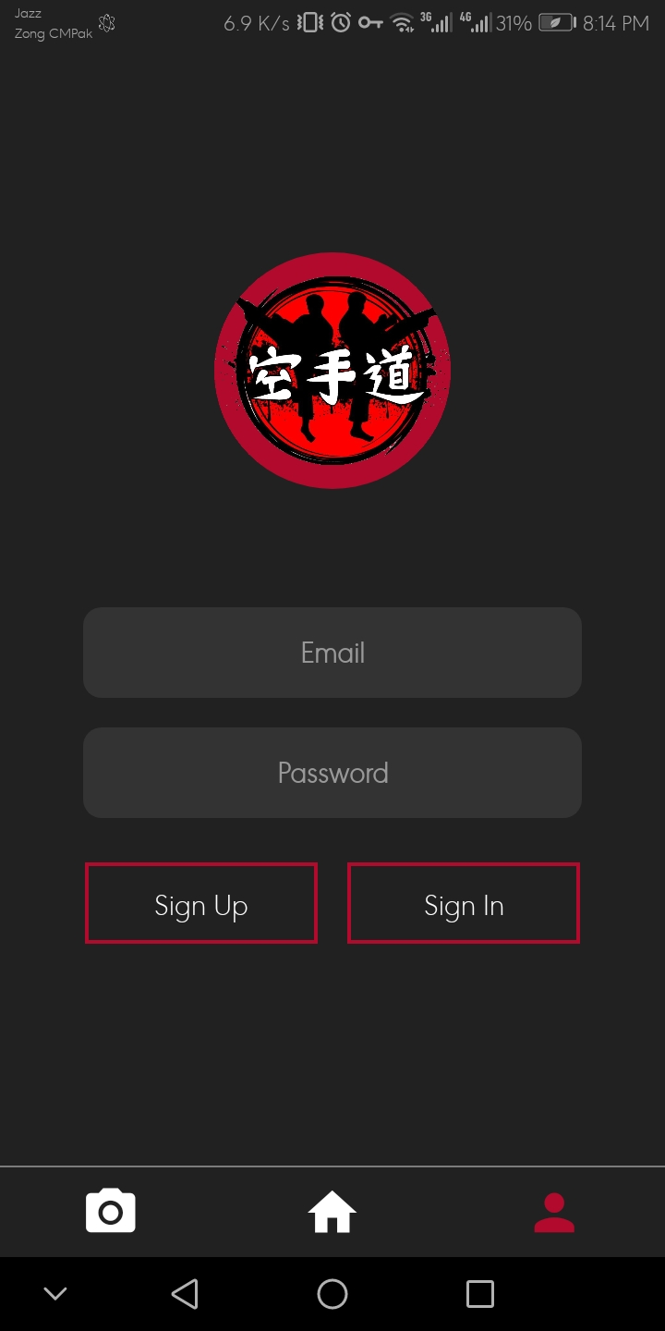

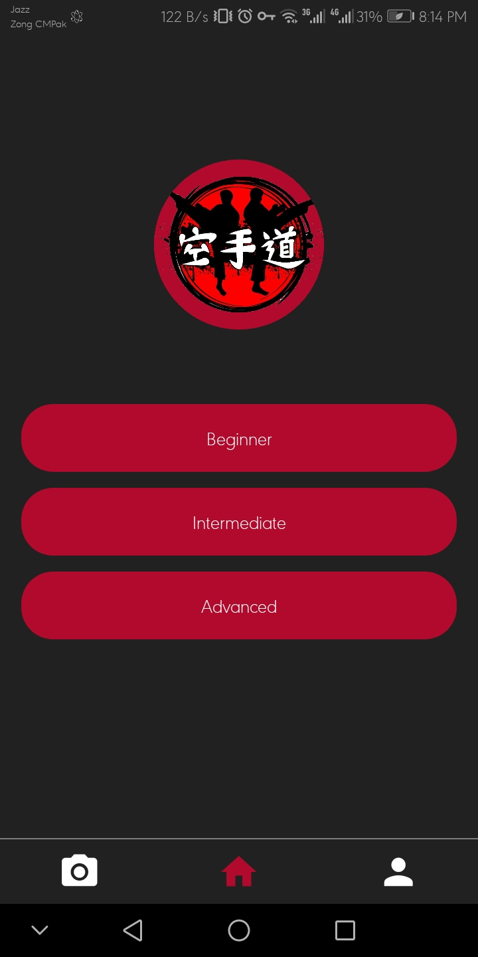

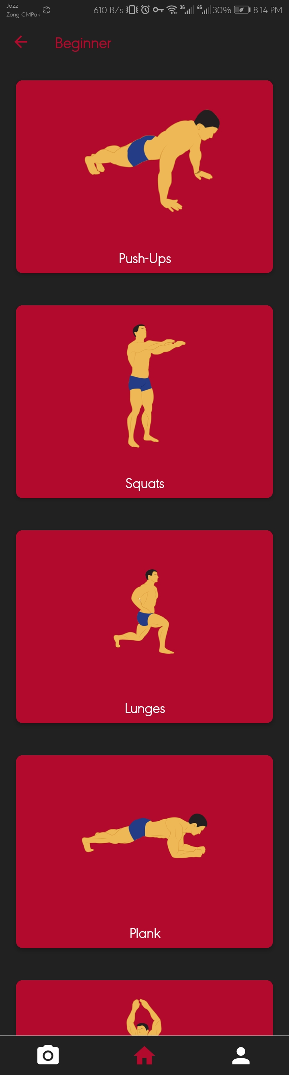

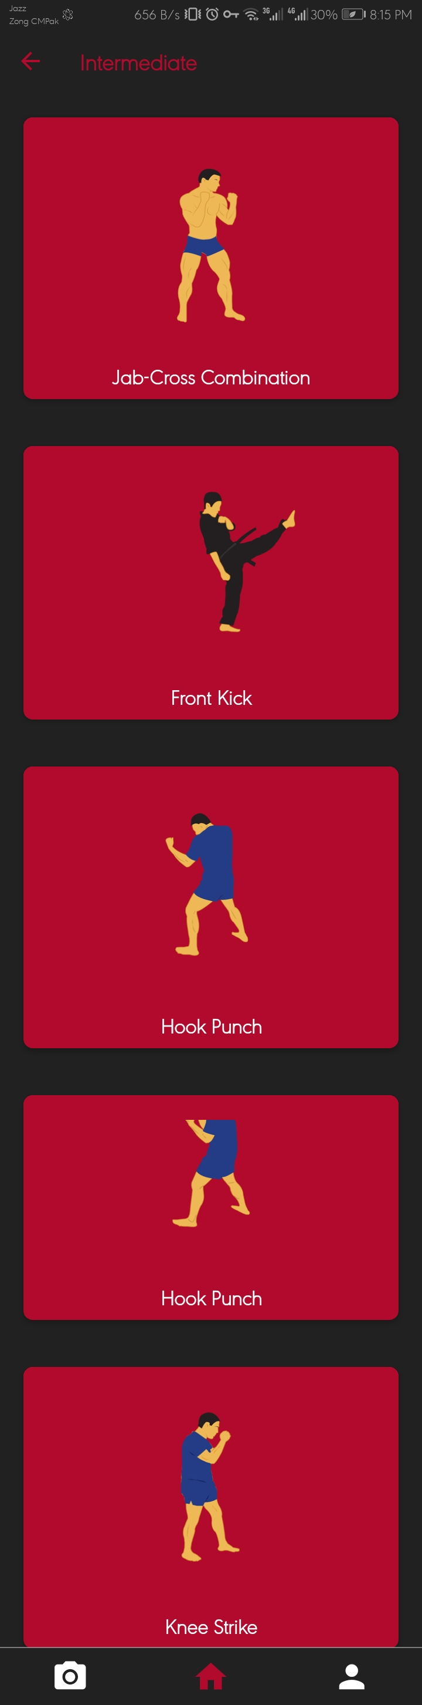

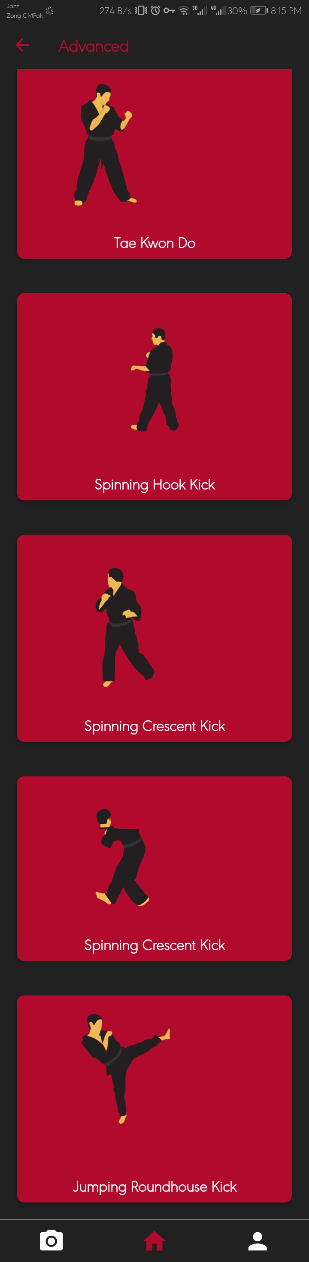
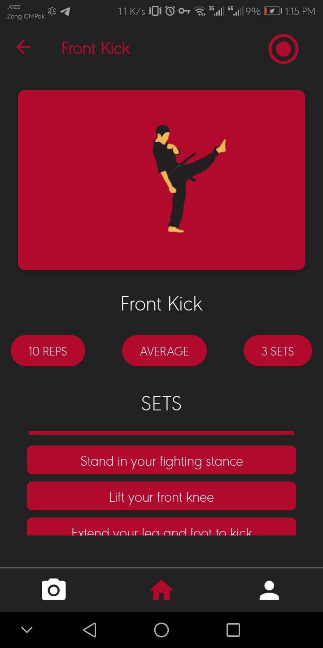

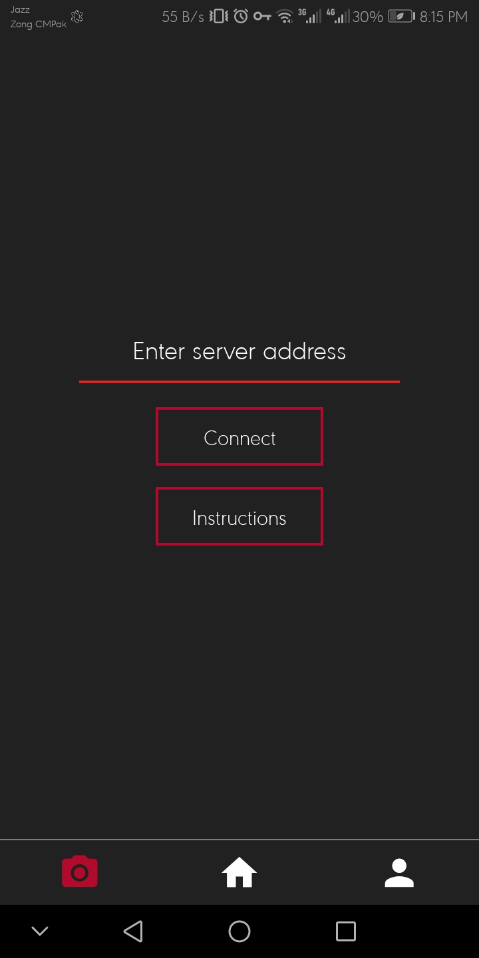

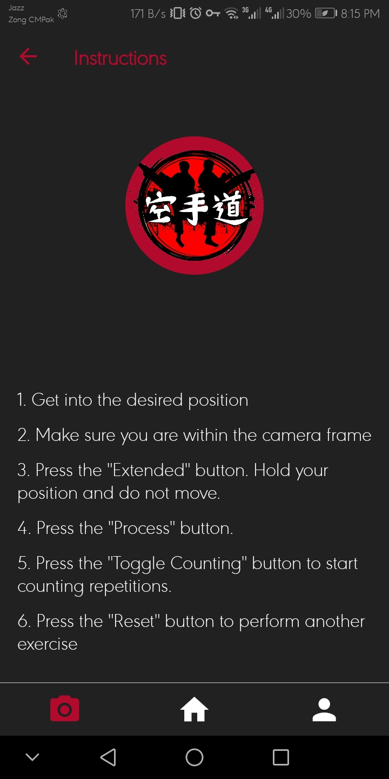

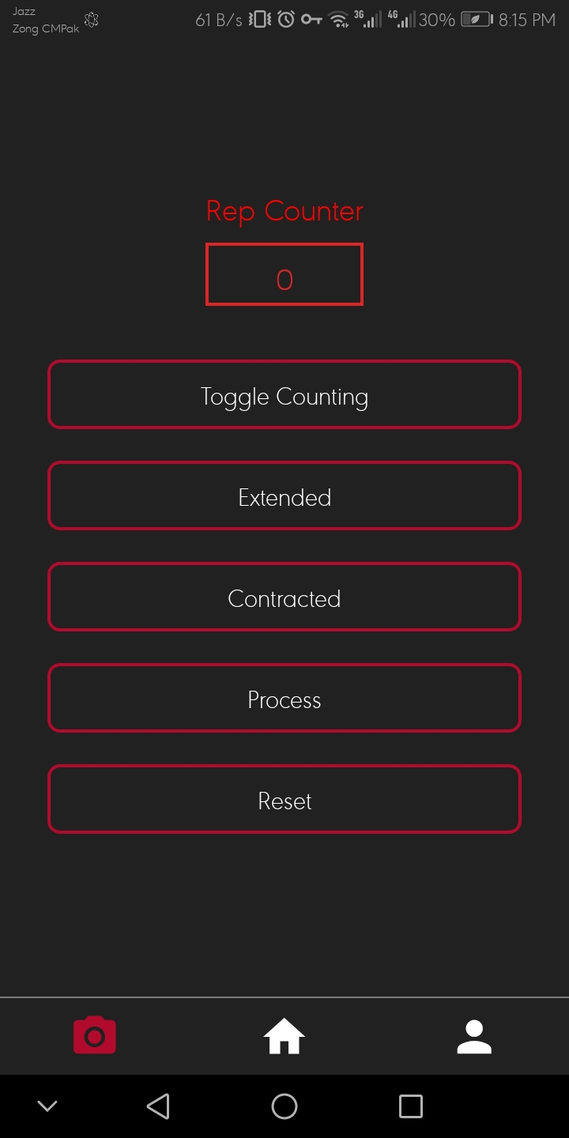

Appendix B: IV & V Report
(Independent verification & validation)
IV & V Resource

Name Signature

S# | Defect Description | Origin Stage | Status | Fix Time
 |  |  |  | Hours | Minutes
1
2
3
…

Table B.1: List of non-trivial defects

This document has been adapted from the following:
- Previous project templates at UCP
- High-level Technical Design, Centers for Medicare & Medicaid Services. (www.cms.gov)

